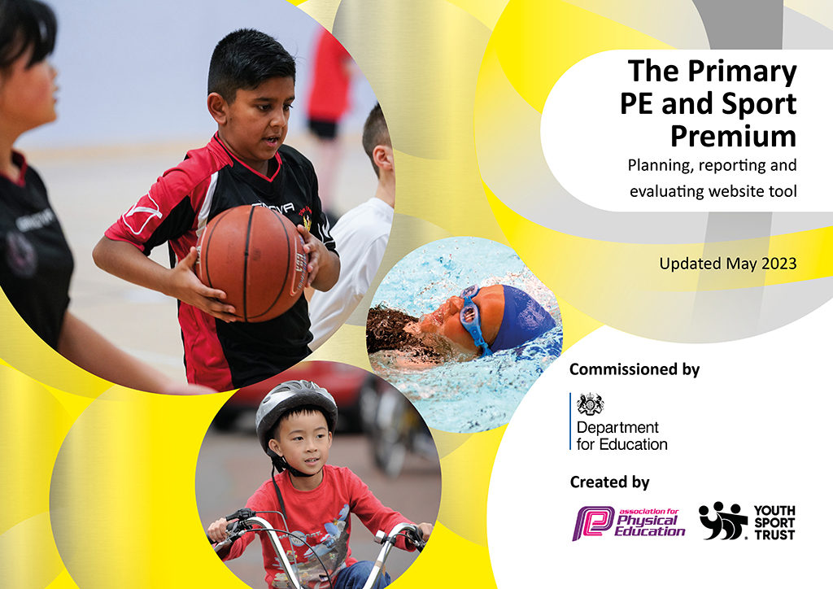
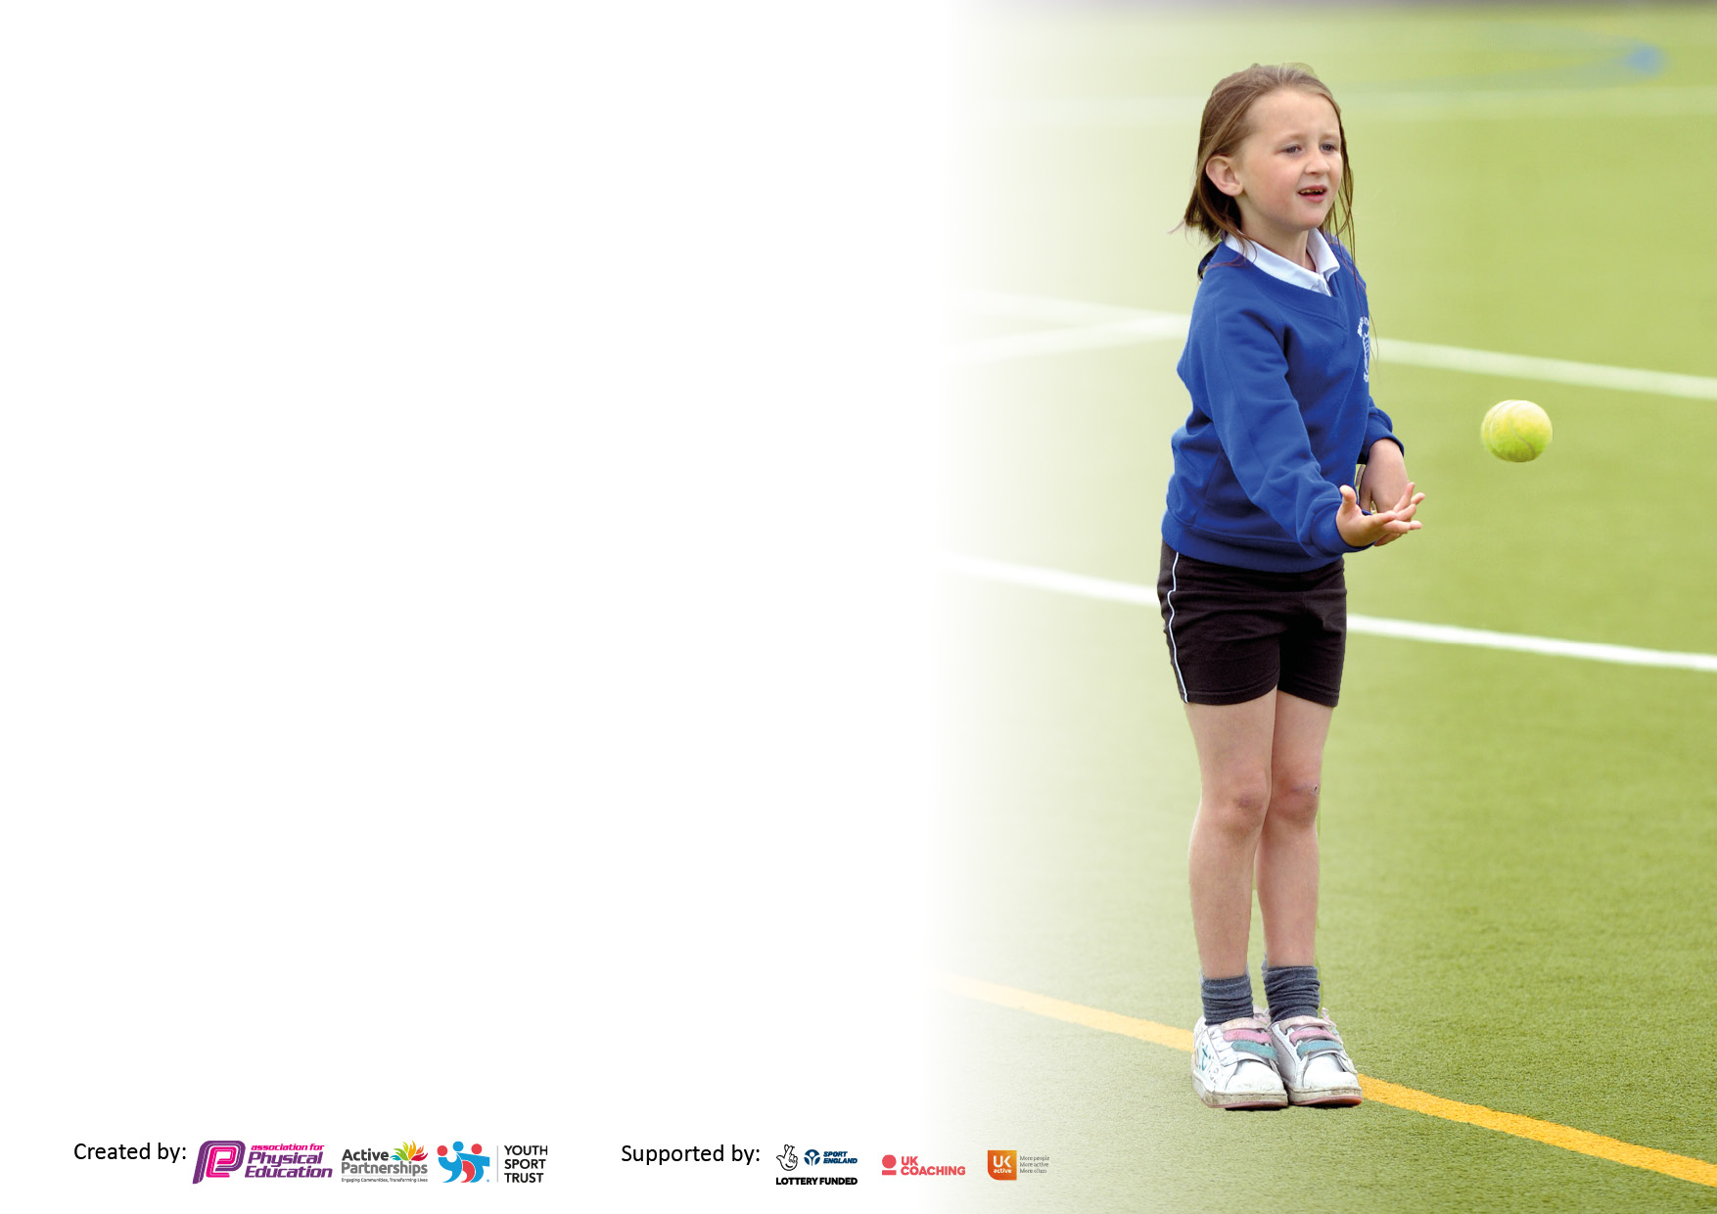

It is important that your grant is used effectively and based on school need. The Education Inspection Framework makes clear there will be a focus on ‘whether leaders and those responsible for governors all understand their respective roles and perform these in a way that enhances the effectiveness of the school’.

Under the Quality of Education Ofsted inspectors consider:
Intent - Curriculum design, coverage and appropriateness
Implementation - Curriculum delivery, Teaching (pedagogy) and Assessment
Impact - Attainment and progress

To assist schools with common transferable language this template has been developed to utilise the same three headings which should make your plans easily transferable between working documents.

Schools must use the funding to make additional and sustainable improvements to the quality of Physical Education, School Sport and Physical Activity (PESSPA) they offer. This means that you should use the Primary PE and sport premium to:

- Develop or add to the PESSPA activities that your school already offer
- Build capacity and capability within the school to ensure that improvements made now will benefit pupils joining the school in future years
- The Primary PE and sport premium should not be used to fund capital spend projects; the school’s budget should fund these.

Please visit gov.uk for the revised DfE guidance including the5keyindicatorsacrosswhichschoolsshoulddemonstrate an improvement. This document will helpyoutoreviewyourprovisionandtoreportyourspend.DfEencouragesschools to use this template as an effective way of meeting the reporting requirements of the Primary PE and Sport Premium.

We recommend you start by reflecting on the impact of current provision and reviewing the previous spend.

Schools are required to publish details of how they spend this funding, including any under-spend from 2021/2022, as well as on the impact it has on pupils’ PE and sport participation and attainment. The funding should be spent by 31st July but the DfE has stated that there will be no clawback of any unspent money so this can be carried forward into 2023/24.

We recommend regularly updating the table and publishing it on your website throughout the year. This evidences your ongoing self-evaluation of how you are using the funding to secure maximum, sustainable impact. Final copy must be posted on your website by the end of the academic year and no later than the 31st July 2023. To see an example of how to complete the table please click HERE.

Details with regard to funding
Please complete the table below.

Total amount carried over from 2021/22 | £5,026
Total amount allocated for 2021/22 | £17,532
How much (if any) do you intend to carry over from this total fund into 2022/23? | £6,296
Total amount allocated for 2022/23 | £17,449
Total amount of funding for 2022/23. Ideally should be spent and reported on by 31st July 2023. | £23,779
Swimming Data
Please report on your Swimming Data below.

Meeting national curriculum requirements for swimming and water safety.

N.B. Complete this section to your best ability. For example you might have practised safe self-rescue techniques on dry land which you can then transfer to the pool when school swimming restarts.
Due to exceptional circumstances priority should be given to ensuring that pupils can perform safe self rescue even if they do not fully meet the first two requirements of the NC programme of study
What percentage of your current Year 6 cohort swim competently, confidently and proficiently over a distance of at least 25 metres?  N.B. Even though your pupils may swim in another year please report on their attainment on leaving primary school at the end of the summer term 2023.  Please see note above | 8%
What percentage of your current Year 6 cohort use a range of strokes effectively [for example, front crawl, backstroke and breaststroke]?  Please see note above | 8%
What percentage of your current Year 6 cohort perform safe self-rescue in different water-based situations? | %
Schools can choose to use the Primary PE and sport premium to provide additional provision for swimming but this must be for activity over and above the national curriculum requirements. Have you used it in this way? | Yes/No

Action Plan and Budget Tracking
Capture your intended annual spend against the 5 key indicators. Clarify the success criteria and evidence of impact that you intend to measure to evaluate for pupils today and for the future.

Academic Year: 2022/23 | Total fund allocated: | Date Updated:
Key indicator 1: The engagement of all pupils in regular physical activity – Chief Medical Officers guidelines recommend that primary school pupils undertake at least 30 minutes of physical activity a day in school |  |  |  | Percentage of total allocation:
 |  |  |  | 72%
Intent | Implementation |  | Impact
Your school focus should be clear what you want the pupils to know and be able to do and about  what they need to learn and to  consolidate through practice: | Make sure your actions to achieve are linked to your intentions: | Funding allocated: | Evidence of impact: what do pupils now know and what can they now do? What has changed?: | Sustainability and suggested next steps:
To provide after school sports clubs across the school, three times a week.  Children will be canvassed for which sports they would like to participate in.  High Quality PE delivered to all our children  All children are given 30 minutes a day of physical activity.  To refine their motor skills through the use of a range of playtime equipment. | PE specialists deliver high quality after school clubs , which meet the needs of the children in different year groups.  PE lessons are delivered by a combination of our school staff and will be delivered by external coaches  Members of staff take their classes out for a Daily Mile  Children are taught how to use a range of playtime equipment safely and appropriately | £17,015 | Children have high quality PE instruction weekly after school and there is participation in them.  All children receive expert PE tuition. Children are able to demonstrate greater proficiency in PE.  Children complete 30 minutes exercise daily  Children use a range of playtime equipment safely and appropriately | Develop a network of schools who wish to participate in competitions and PE related activities.  PE Coaches are available to provide high quality CPD as requested  Ensure that staff allocate time on their weekly timetables  Ensure that staff are regularly reminded to engage the children
Key indicator 2: The profile of PESSPA being raised across the school as a tool for whole school improvement |  |  |  | Percentage of total allocation:
 |  |  |  | %
Intent | Implementation |  | Impact
Your school focus should be clear what you want the pupils to know and be able to do and about  what they need to learn and to  consolidate through practice: | Make sure your actions to achieve are linked to your intentions: | Funding allocated: | Evidence of impact: what do pupils now know and what can they now do? What has changed?: | Sustainability and suggested next steps:
Children have access to high quality lessons through a planned scheme of work. | Scheme of work determined by collaboration between the school and its external PE provider | Costed above | Pupils have clear, well structured sessions that progress skills with clear assessment of skills along the way | CPD for staff provided by external providers to aid delivery of PE.

Key indicator 3: Increased confidence, knowledge and skills of all staff in teaching PE and sport |  |  |  | Percentage of total allocation:
Intent | Implementation |  | Impact
Your school focus should be clear | Make sure your actions to | Funding | Evidence of impact: what do | Sustainability and suggested
what you want the pupils to know | achieve are linked to your | allocated: | pupils now know and what | next steps:
and be able to do and about | intentions: |  | can they now do? What has
what they need to learn and to |  |  | changed?:
consolidate through practice:
High quality teaching and learning for all children | Engagement of a PE specialist | Costed above | Staff members have the opportunity to work alongside specialist PE coaches | To introduce a wide range of activities  Ensure all teachers are kept up to date with all developments in PE.
Key indicator 4: Broader experience of a range of sports and activities offered to all pupils |  |  |  | Percentage of total allocation:
 |  |  |  | 5%
Intent | Implementation |  | Impact
Your school focus should be clear | Make sure your actions to | Funding | Evidence of impact: what do | Sustainability and suggested
what you want the pupils to know | achieve are linked to your | allocated: | pupils now know and what | next steps:
and be able to do and about | intentions: |  | can they now do? What has
what they need to learn and to |  |  | changed?:
consolidate through practice:
Children are able to use a broad range of outdoor play equipment at playtimes  Children have increased opportunity to participate in basketball activities | Continuous replenishment and expansion of PE equipment for at playtimes  The children have greater access to fixed play equipment to develop their ball skill (purchase and installation of basketball hoops) | £1000 | Children use a broad range of outdoor play equipment at playtimes  Children have access to participate in increase Basketball activities | Replenishing equipment as it becomes damaged/worn  Continue to encourage children to refine their basketball skills

Key indicator 5: Increased participation in competitive sport |  |  |  | Percentage of total allocation:
 |  |  |  | 2%
Intent | Implementation |  | Impact
Your school focus should be clear | Make sure your actions to | Funding | Evidence of impact: what do | Sustainability and suggested
what you want the pupils to know | achieve are linked to your | allocated: | pupils now know and what | next steps:
and be able to do and about | intentions: |  | can they now do? What has
what they need to learn and to |  |  | changed?:
consolidate through practice:
Children will be taught and then participate in a range of competitive sports | Children are taught a range of competitive sports and participate in them | £360 | Children participate in a range of competitive sports and know the rules that apply to them | Ensure that planning includes the delivery of a range of competitive sports

Signed off by
Head Teacher: | R Green
Date: | 21.7.23
Subject Leader: | D Gains
Date: | 21.7.23
Governor: | L Rouse
Date: | 21.7.23

